Login into Azure: <https://portal.azure.com/>

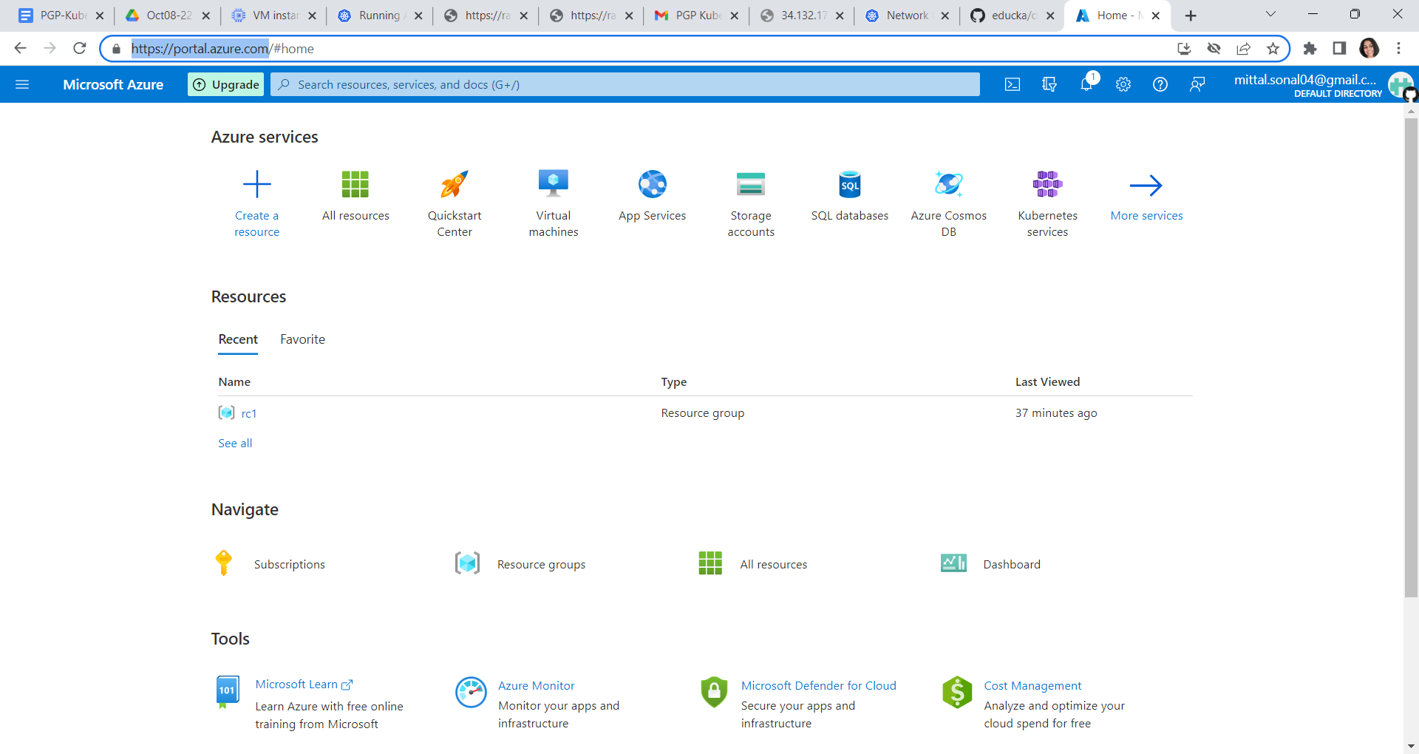

Click on main menu and click on create a resource

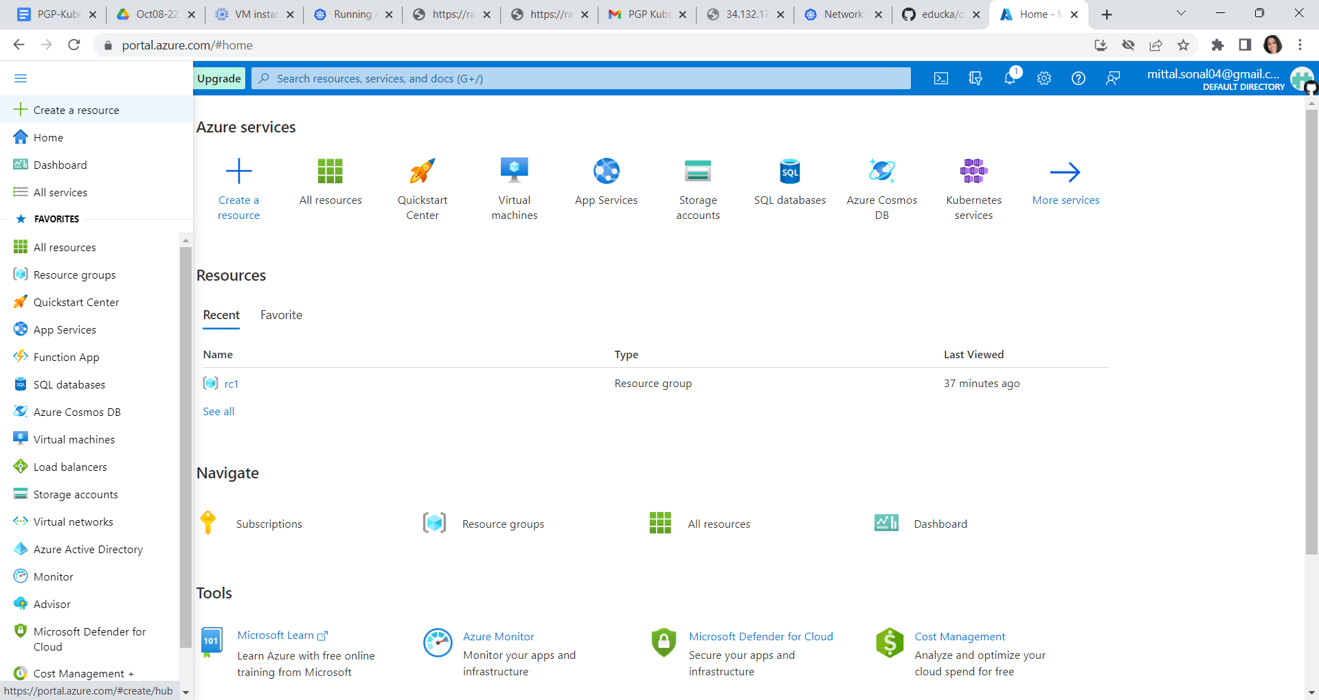

Left side click on Containers

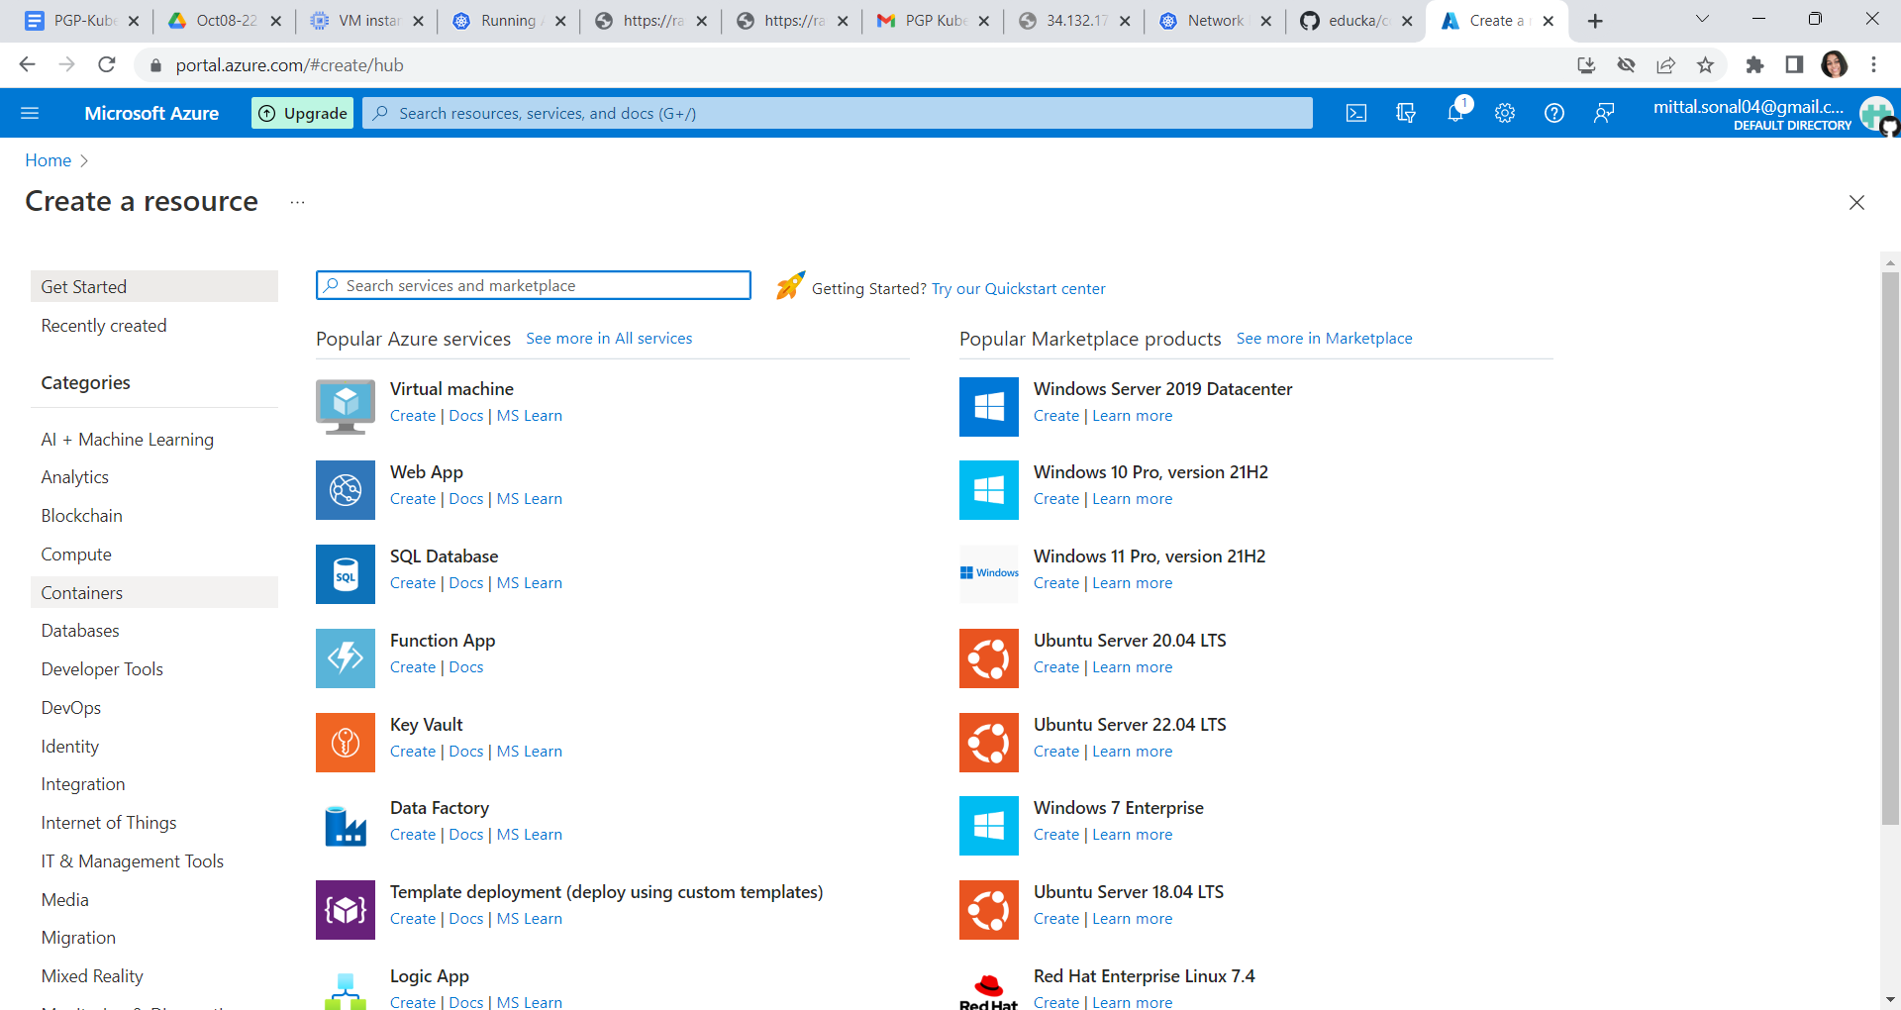

Click on create under Azure kuberentes service(AKS)

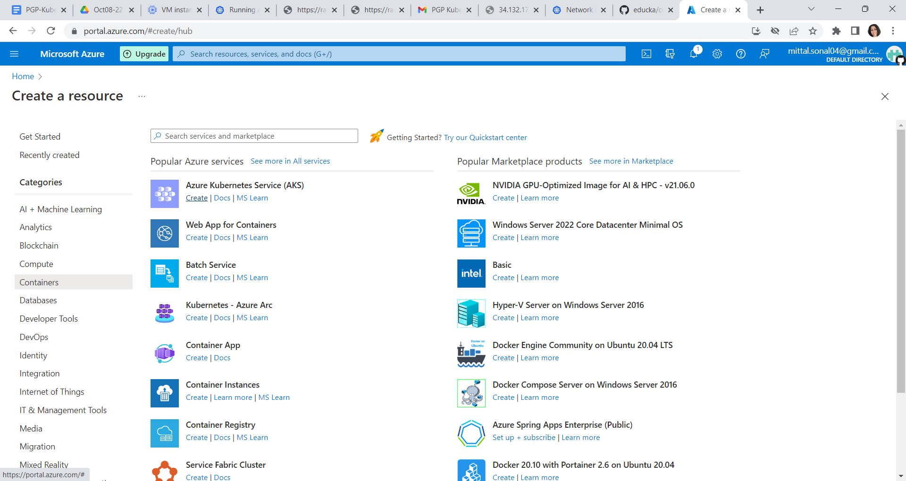

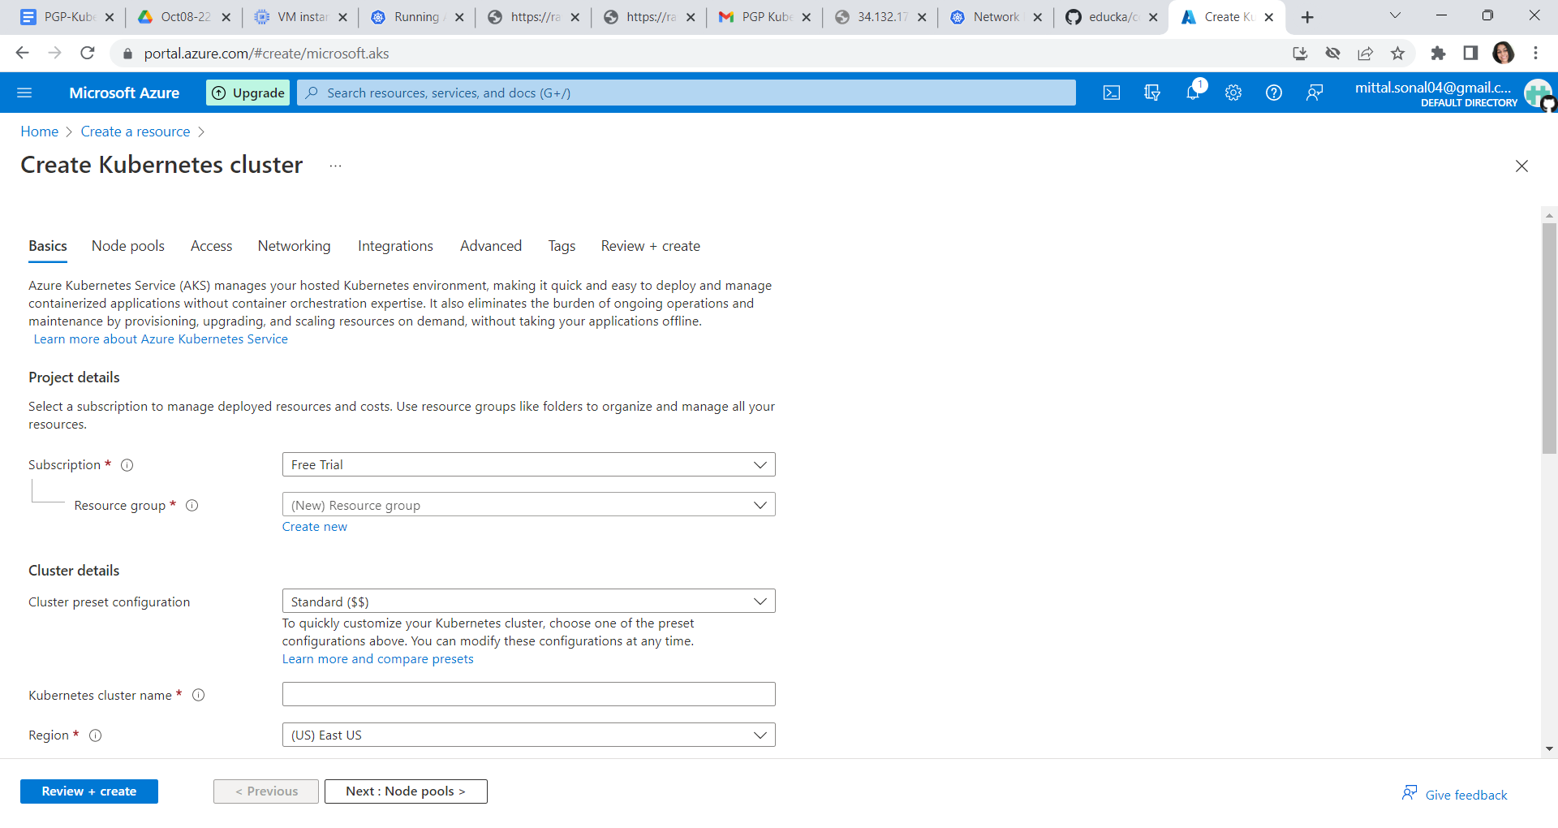

Select following values:

Subscription🡪 leave as same

Click on create New under resource group 🡪 and give a unique name

Clusterdetails🡪 cluster preset configuration -> select Dev/test

Kubernetes Clustername 🡪 cluster1

Region name 🡪 leave it as is

Availability zone : select 1,2,3

Kubernetes version: leave as default

API server availability => select 99.5%

**Primary node pool : select manual and make node count = 1**

**Also click on change size and select vm size as B2s**

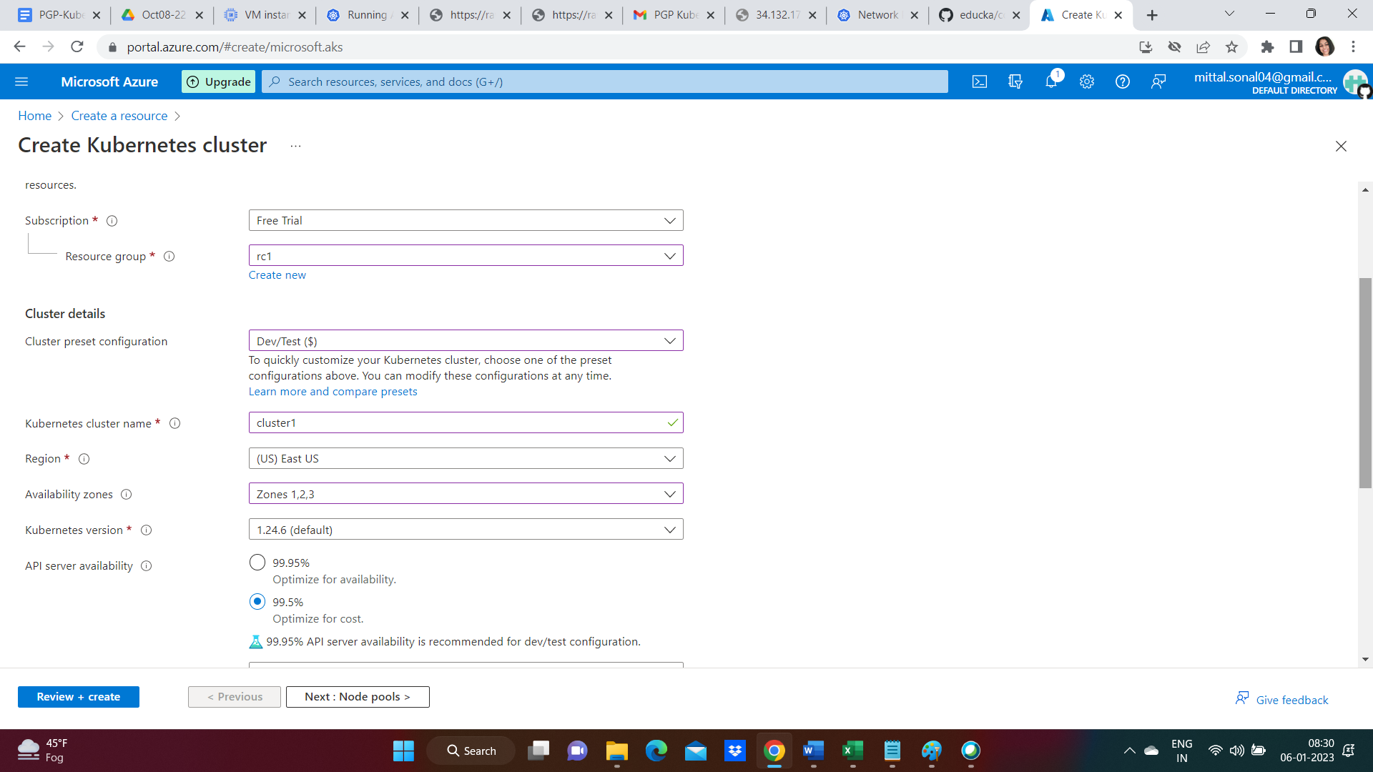

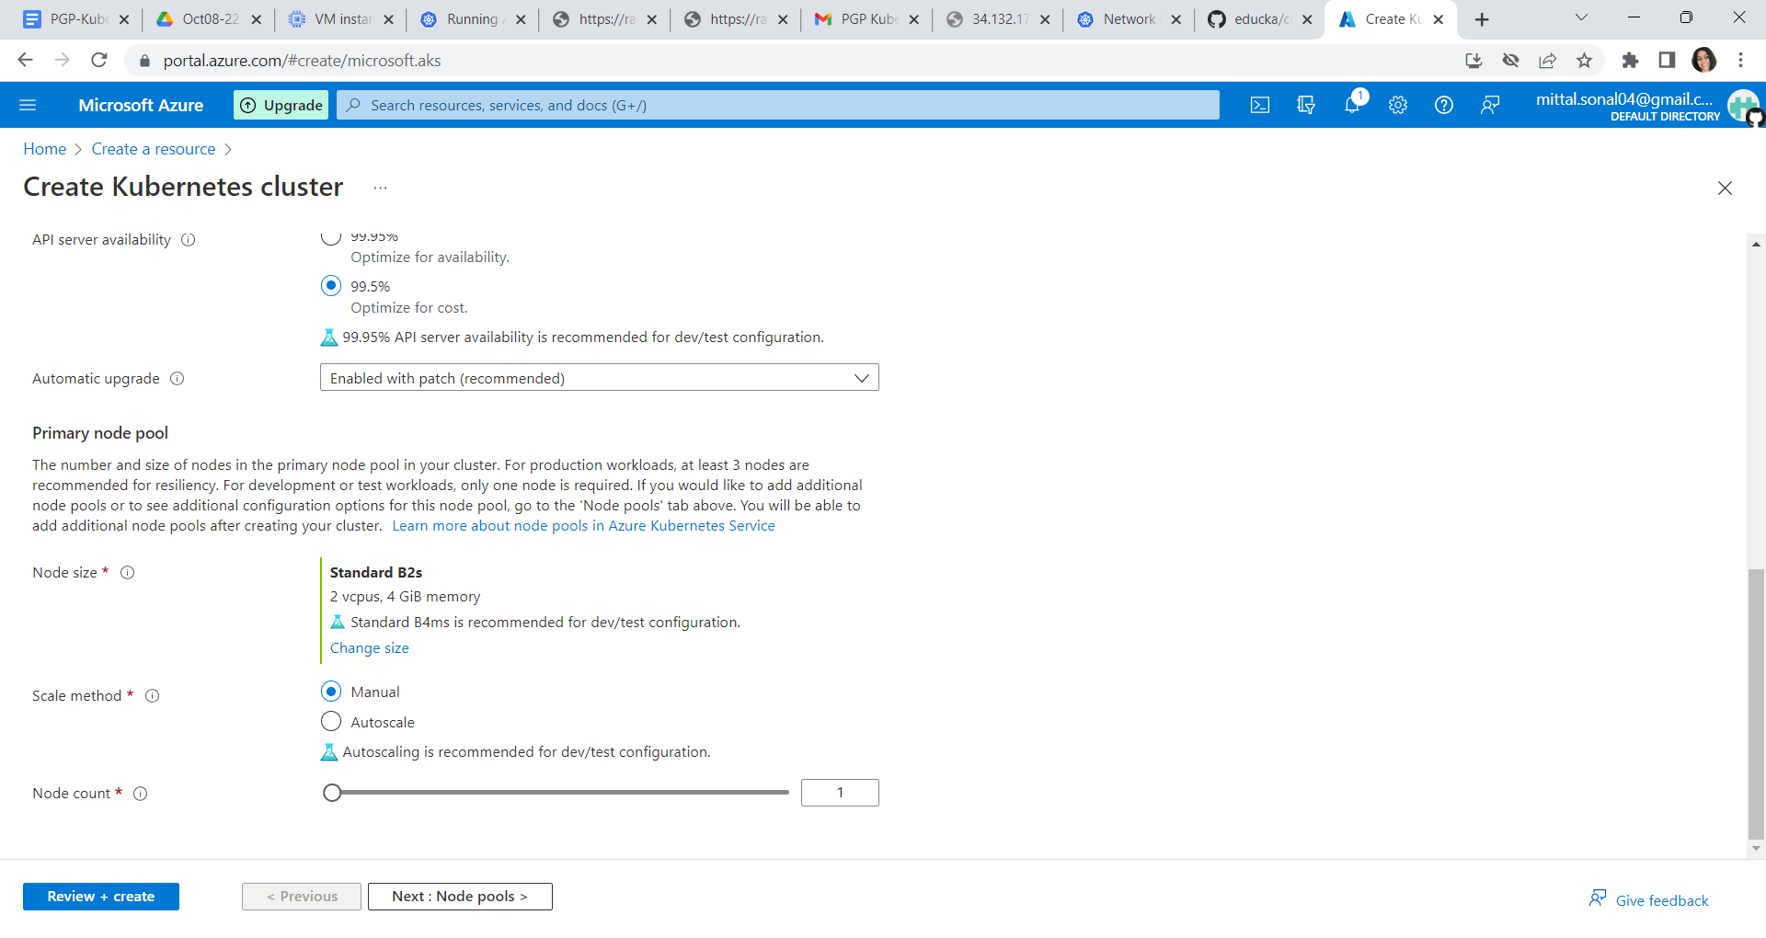

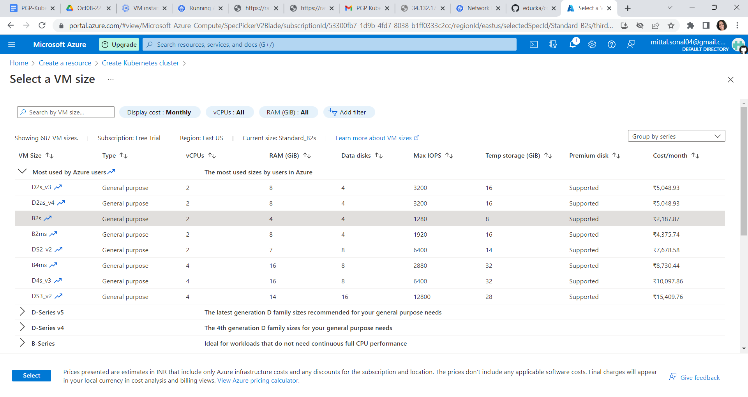

Click next button 🡪 no changes to be done

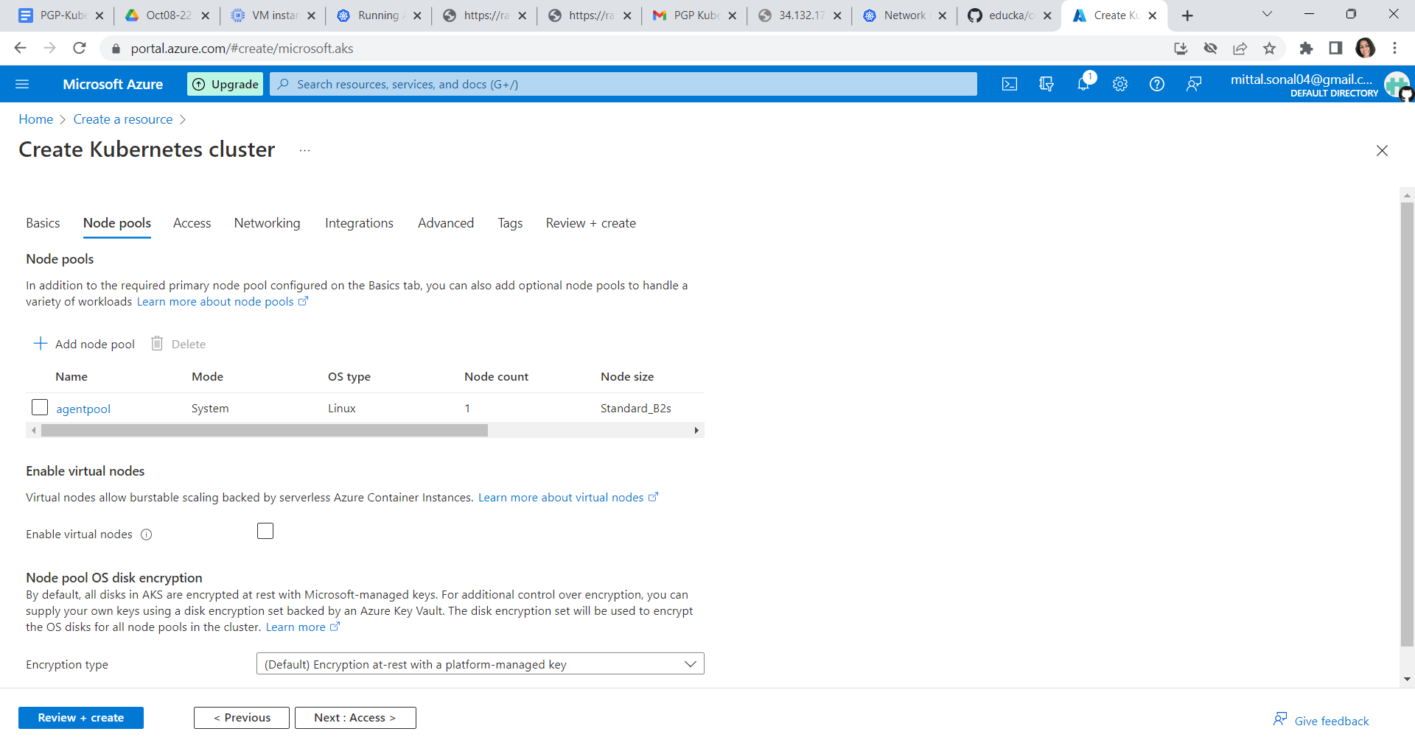

Click on next 🡪 no changes to be done

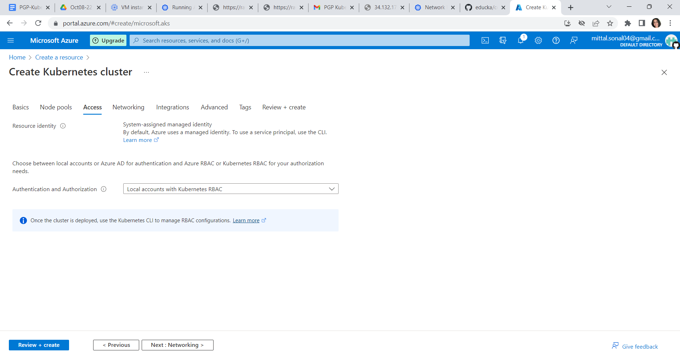

Click on next -> Network 🡪 select kubelet and scroll down to select calico

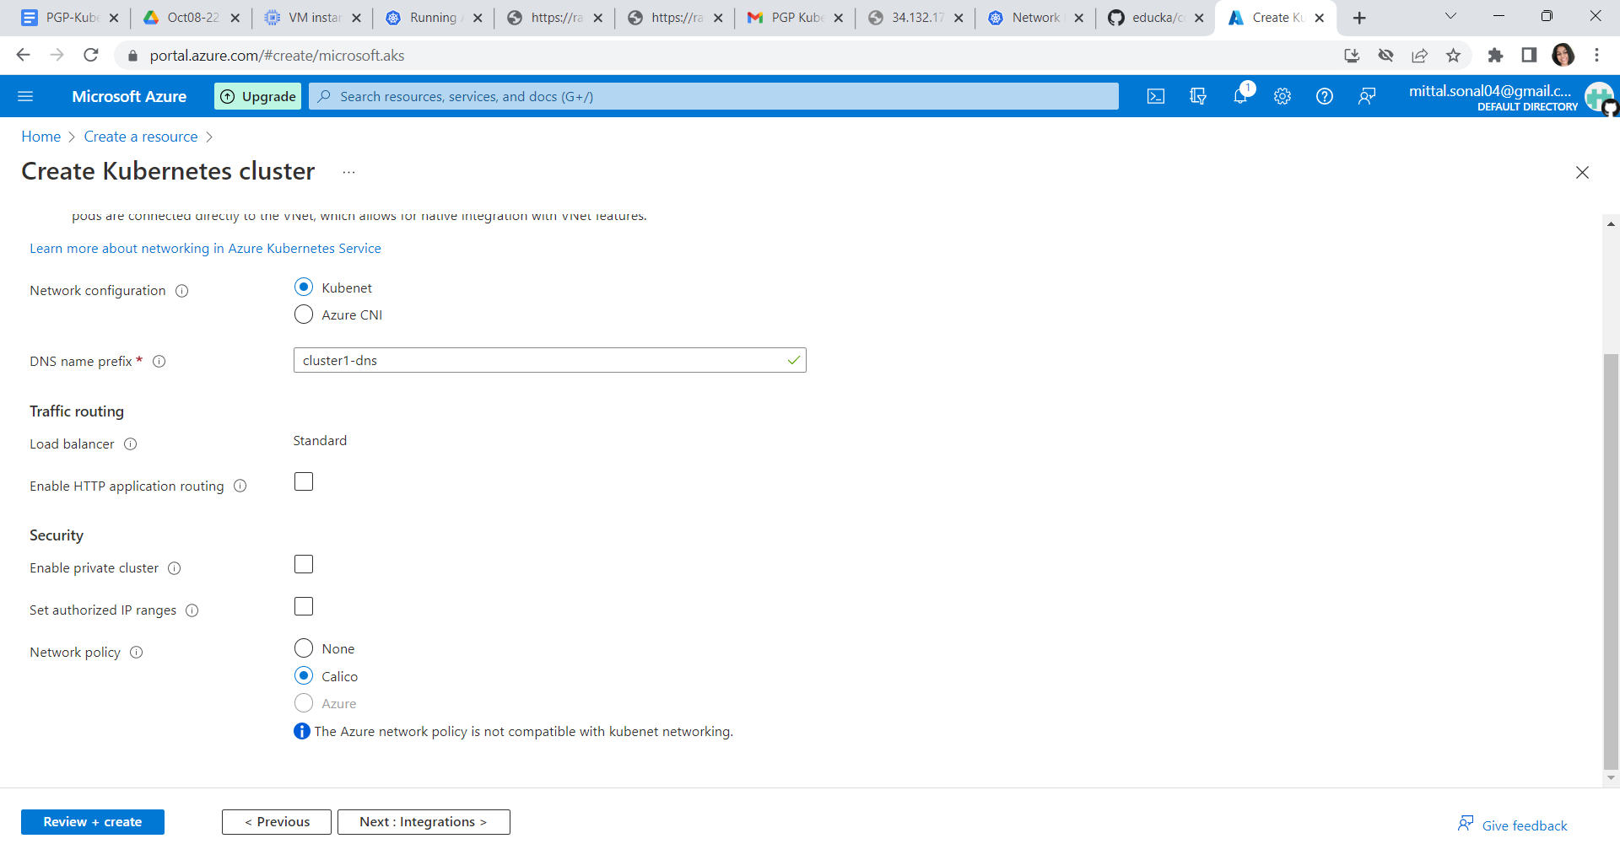

Click next🡪 no changes required

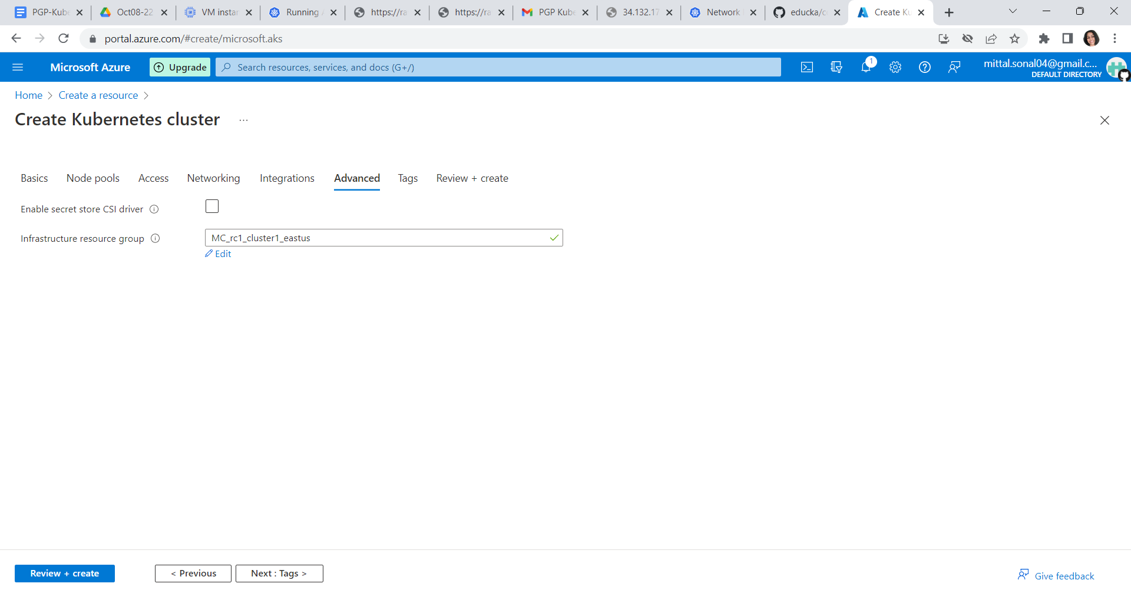

Click next -> no changes required

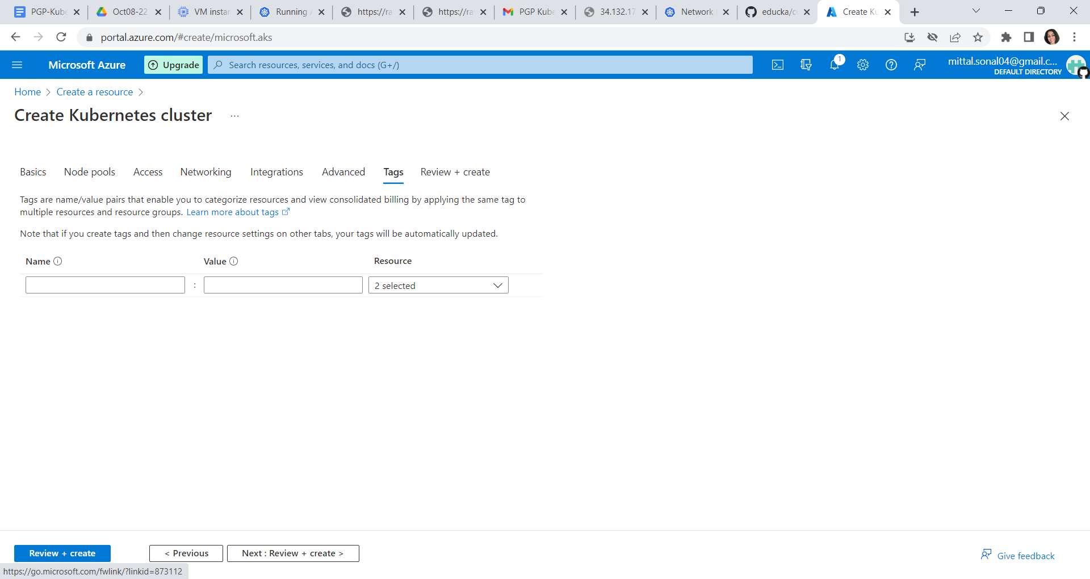

Click on Review and Create button.

It will validate the configuration of Kubernetes cluster

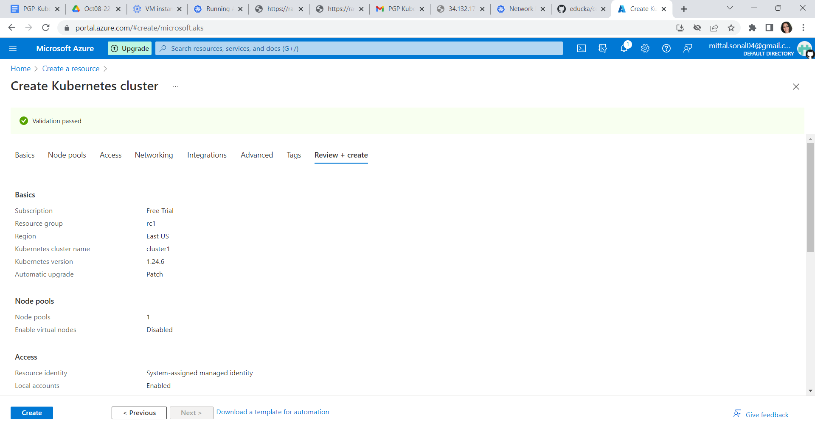

Click on create button now to create the cluster

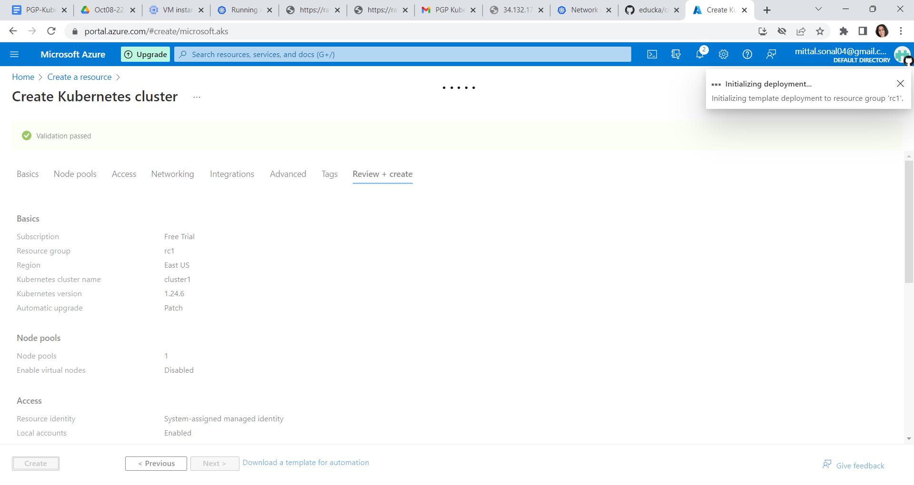

It will take 5 minutes to create the cluster

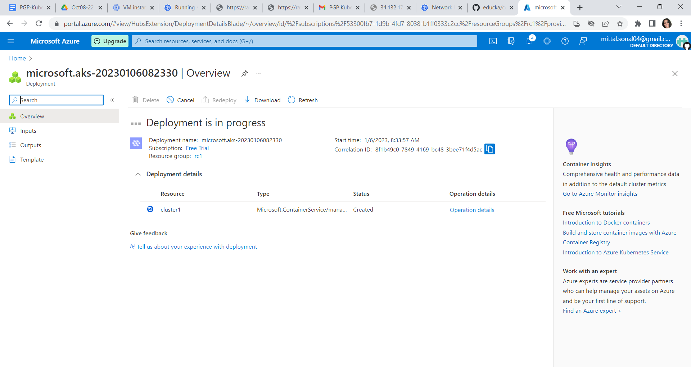

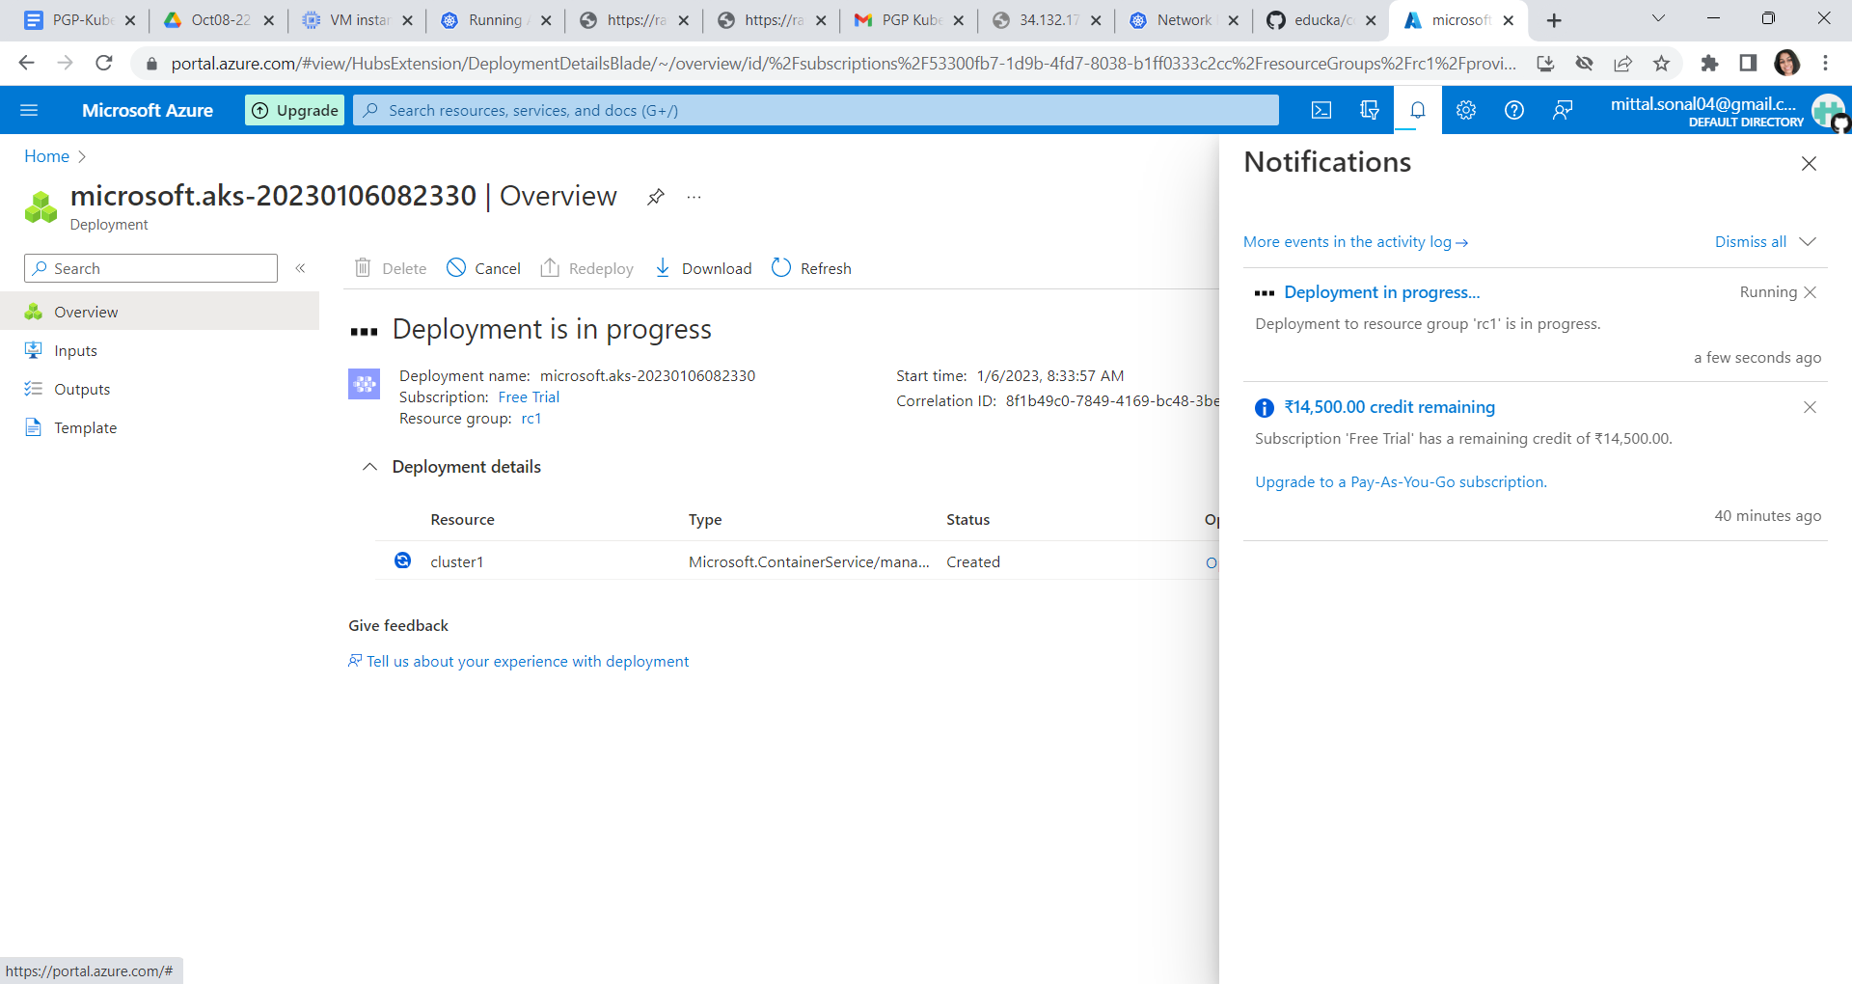

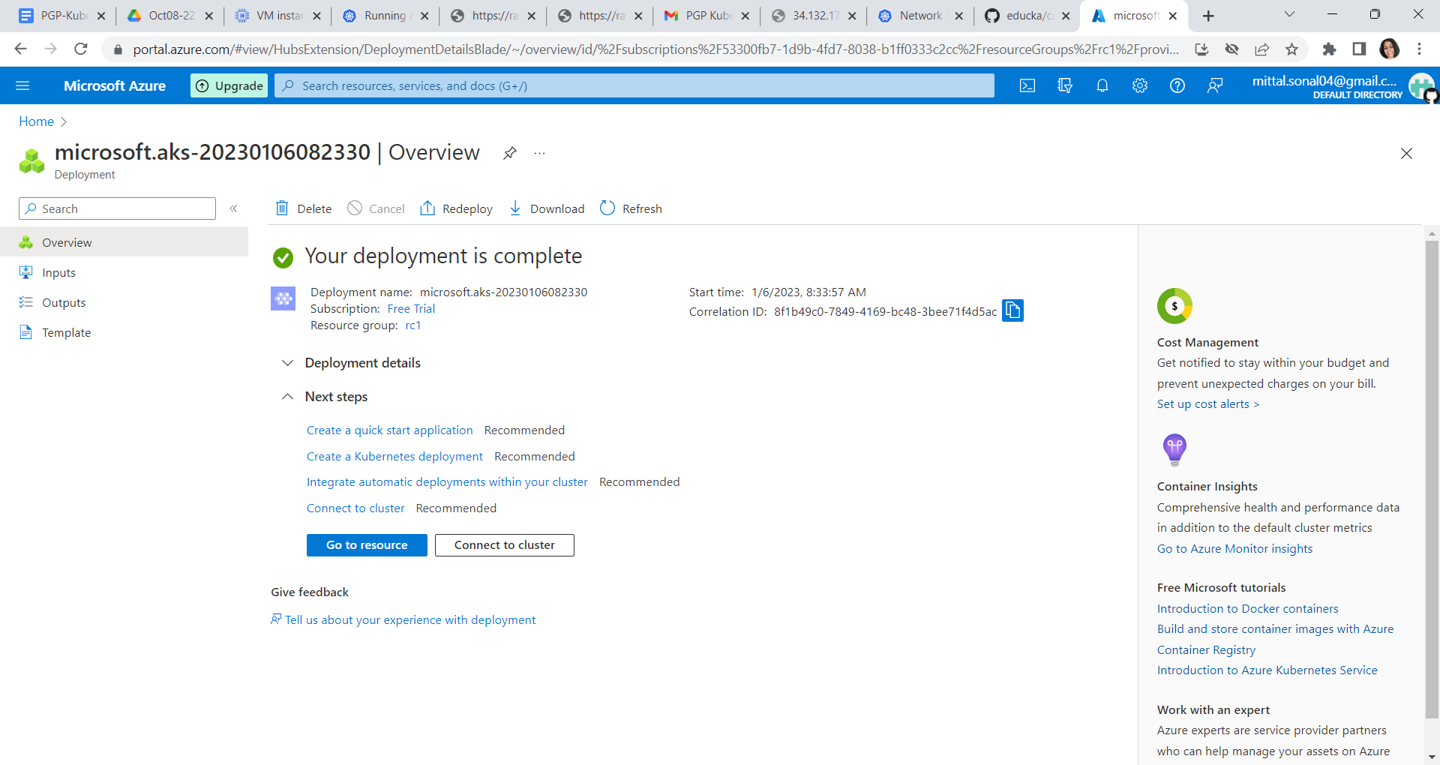

Click on the go to resource



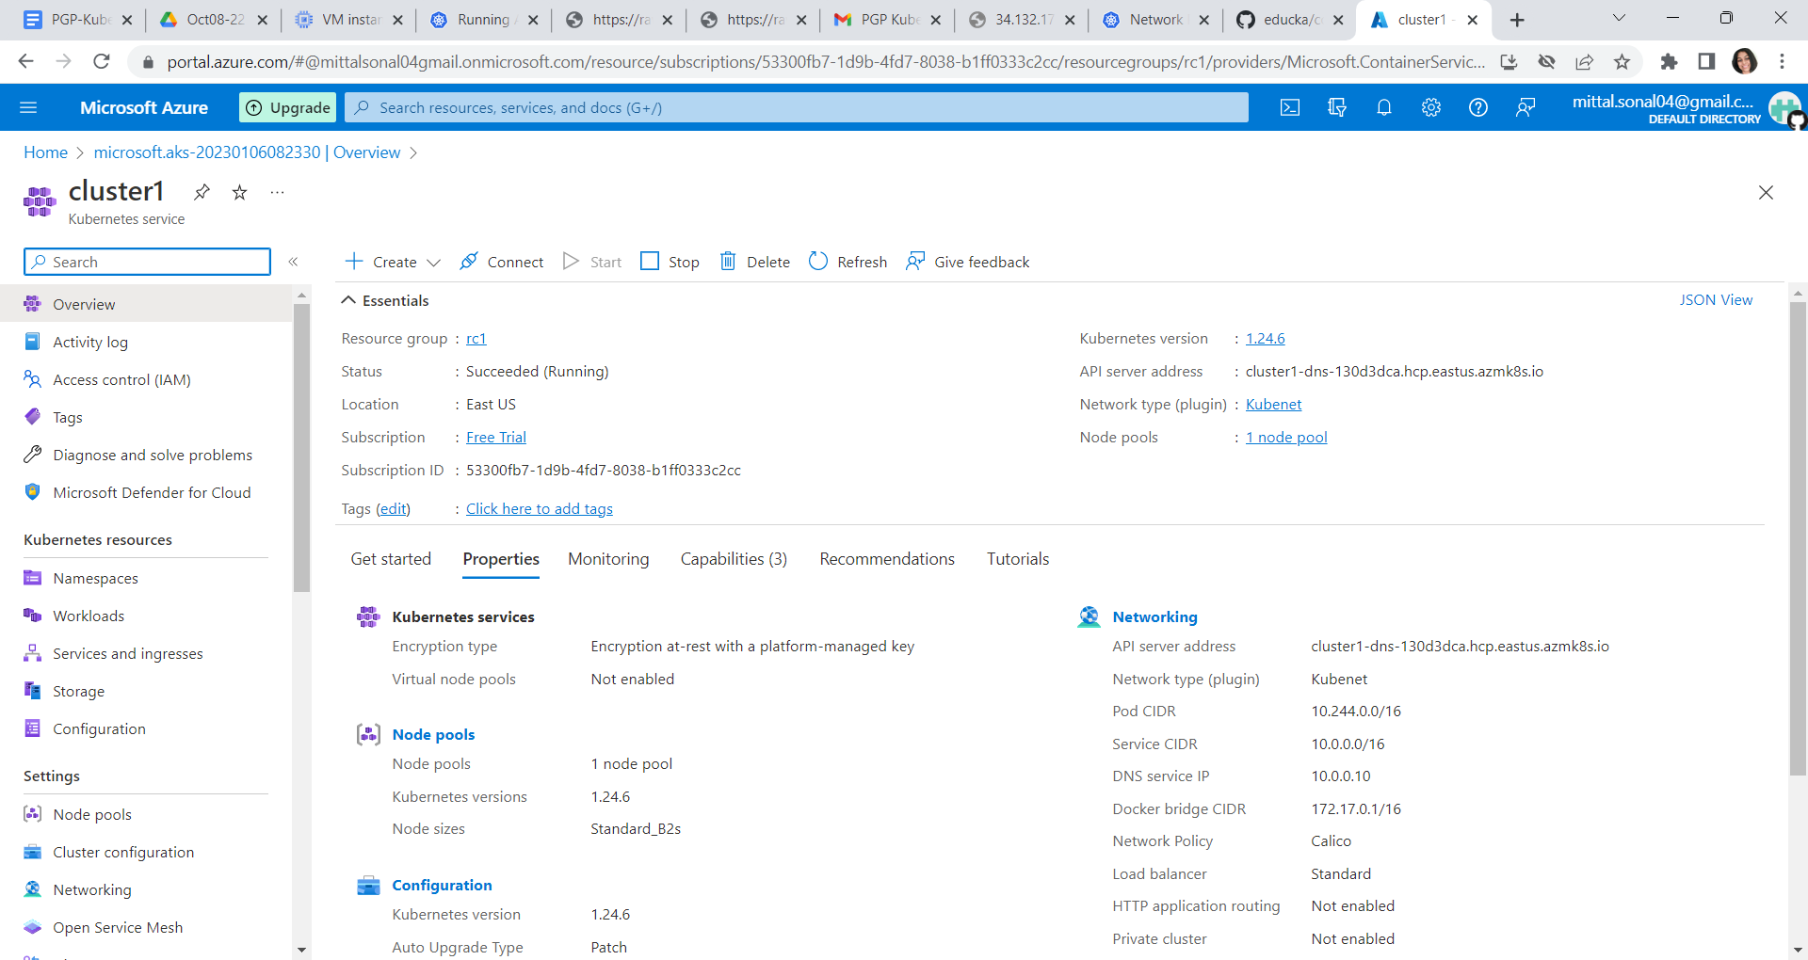

Click on connect button on top

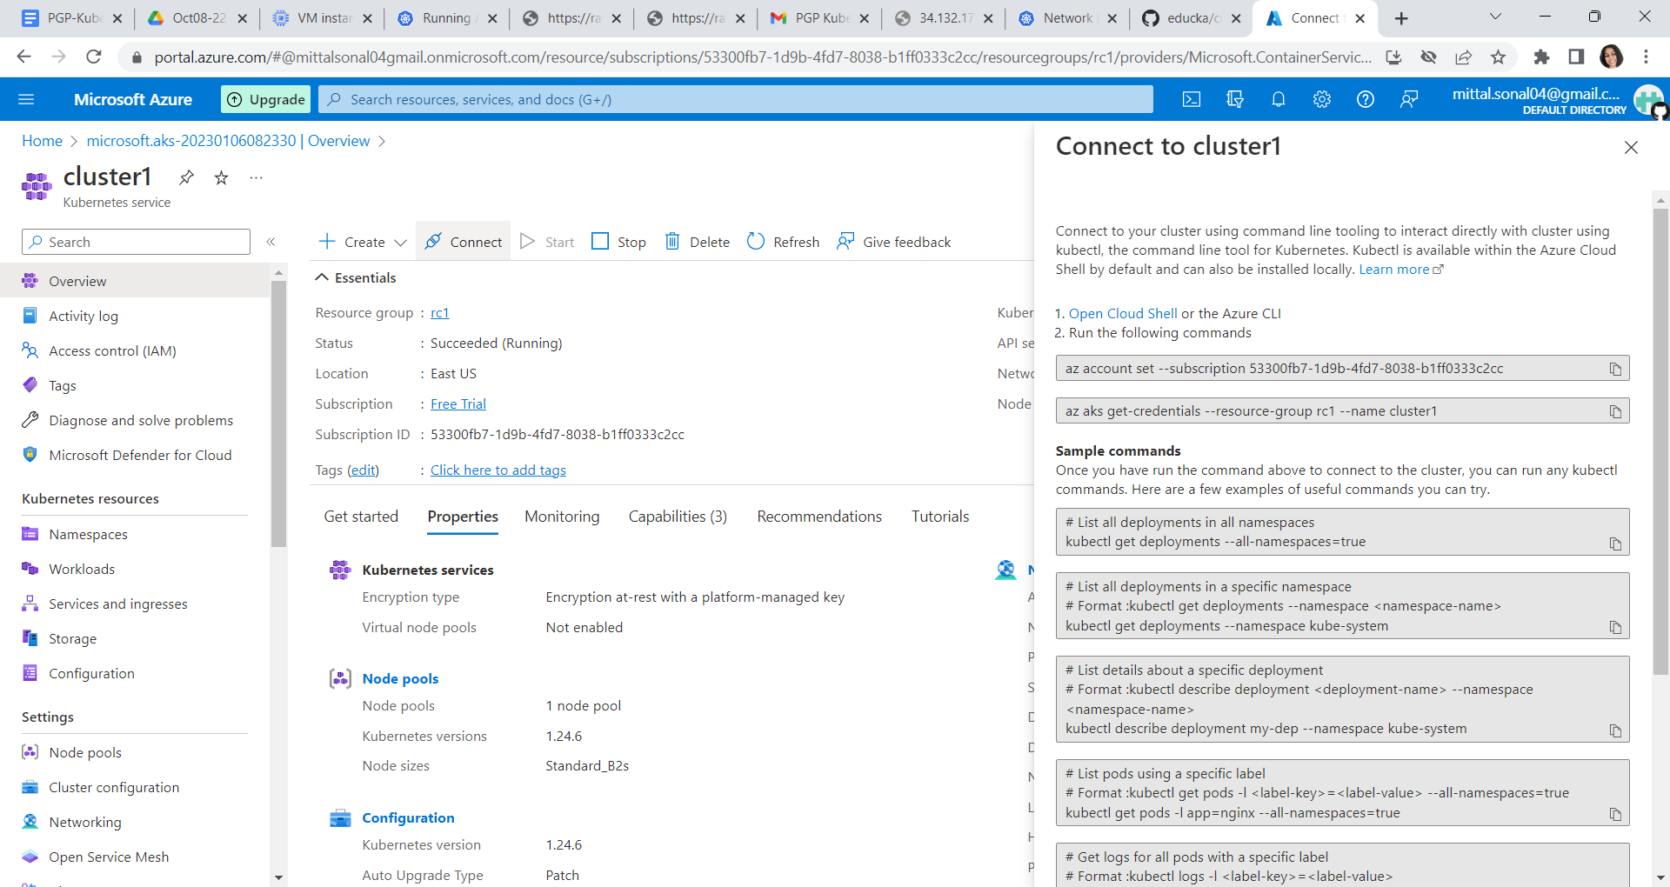

Click on open cloud shell

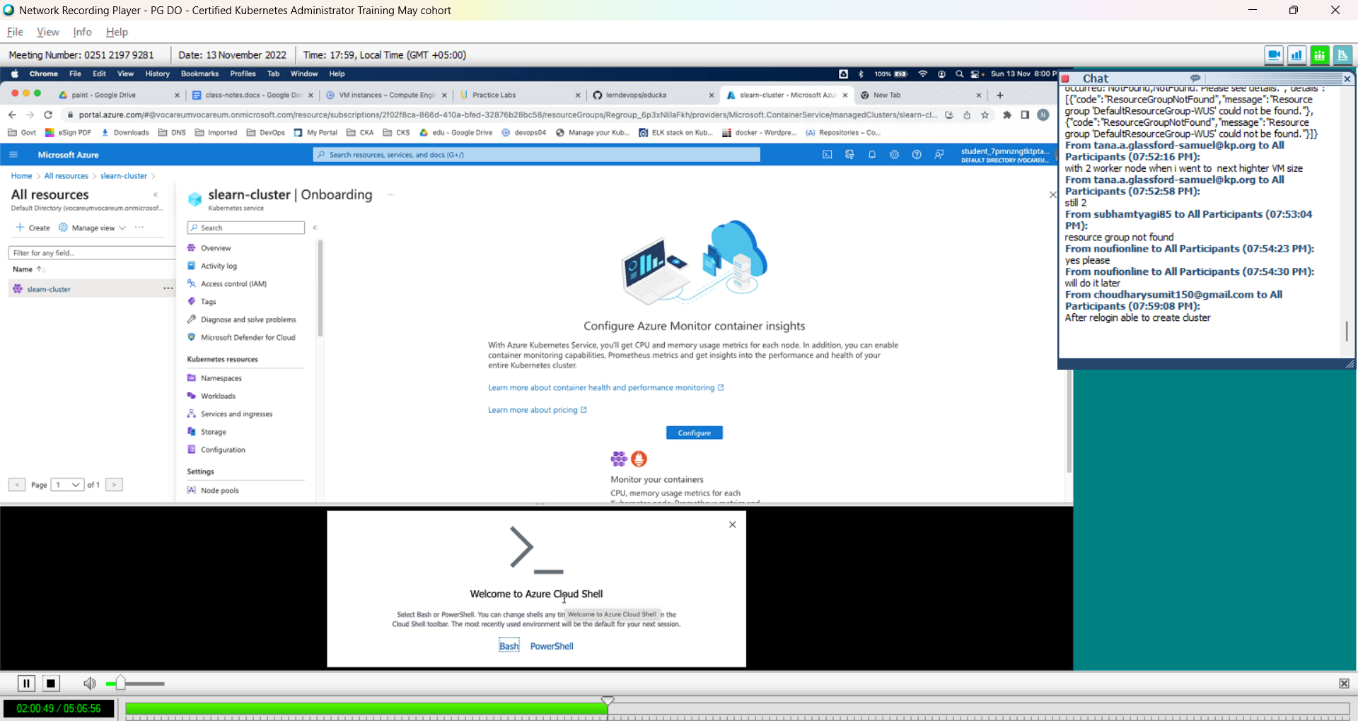

Click on bash

Add the storage, Click on Advance settings🡪 enter any unique value for storage account and unique value for fiel share

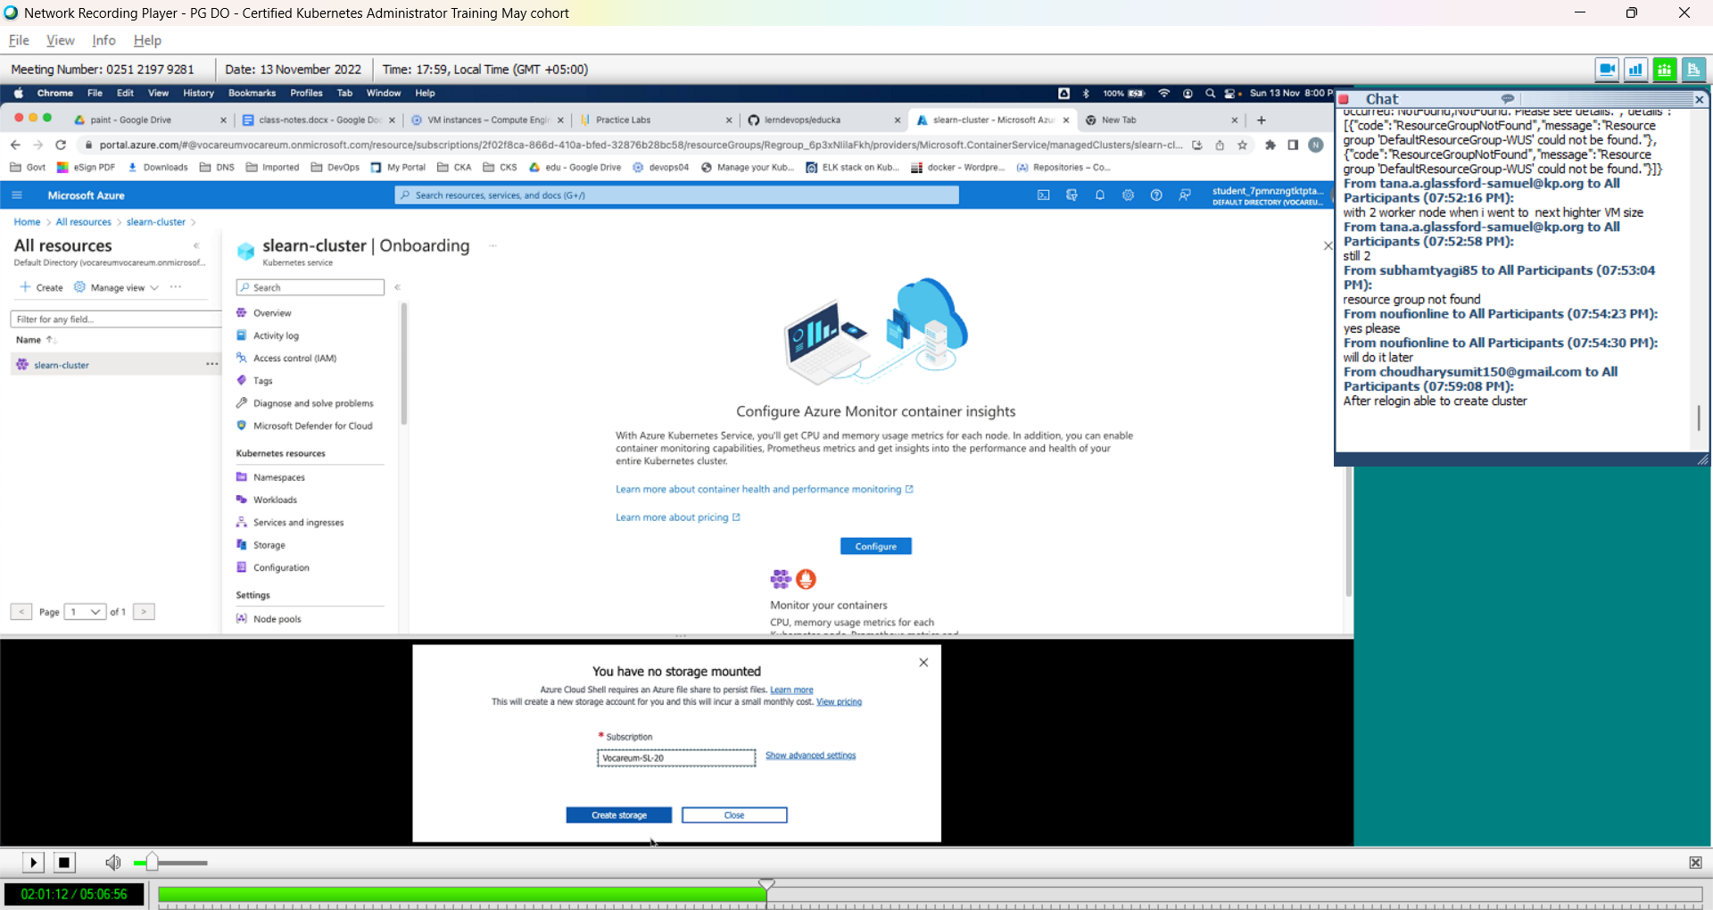

Make sure they are unique so add some extra random characters.

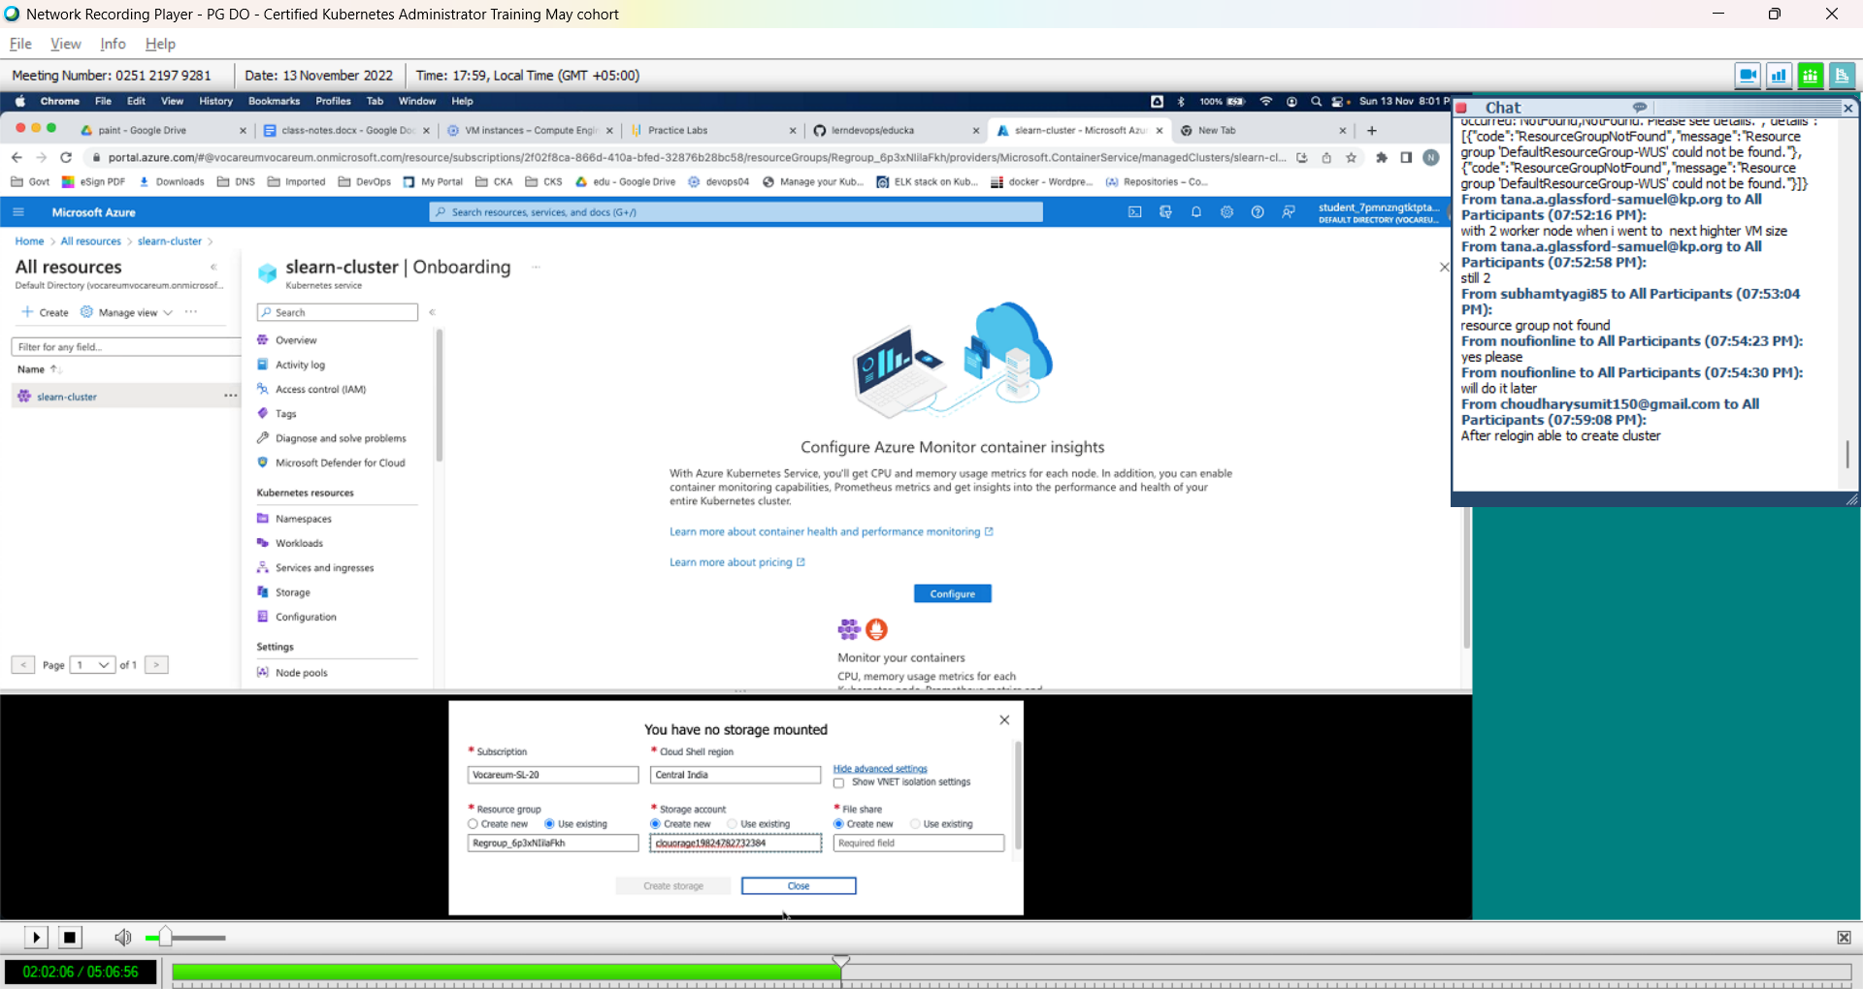

Click on create storage, shell will open

Click on open new session button, to open shell in a new window

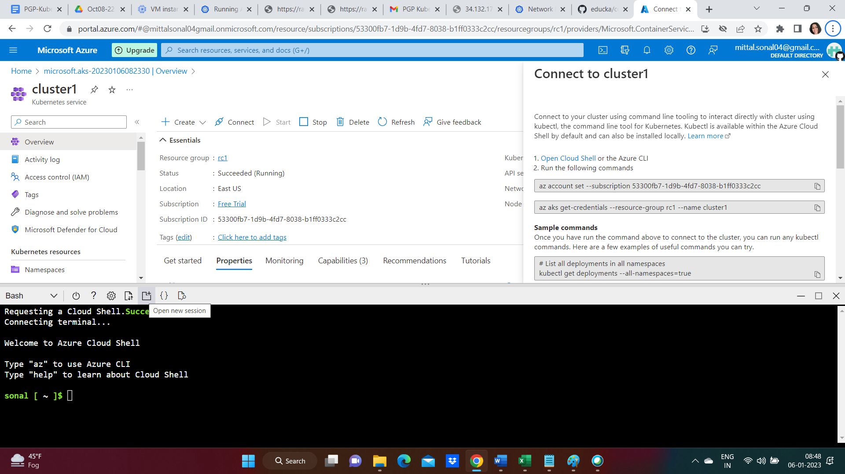

Run the 2 commands given in connect to cluster-1 tab(rightside) in the shell to connect to cluster

az account set --subscription 53300fb7-1d9b-4fd7-8038-b1ff0333c2cc

az aks get-credentials --resource-group rc1 --name cluster1

